Hexagon

Definition
# Source: AI Source: Provided by: [Data Path: Persons Table -> ID Column: 1, Name_En Column: Motasem Essam] -> From: [ChatGPT] on [7/25/2026]
A hexagon is a polygon with six sides, six vertices, and six interior angles.
The name comes from Greek:
- hex = six
- gonia = angle
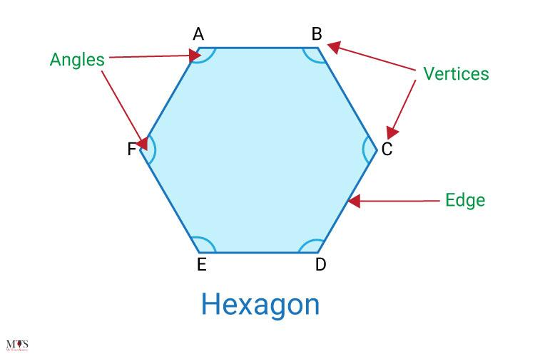
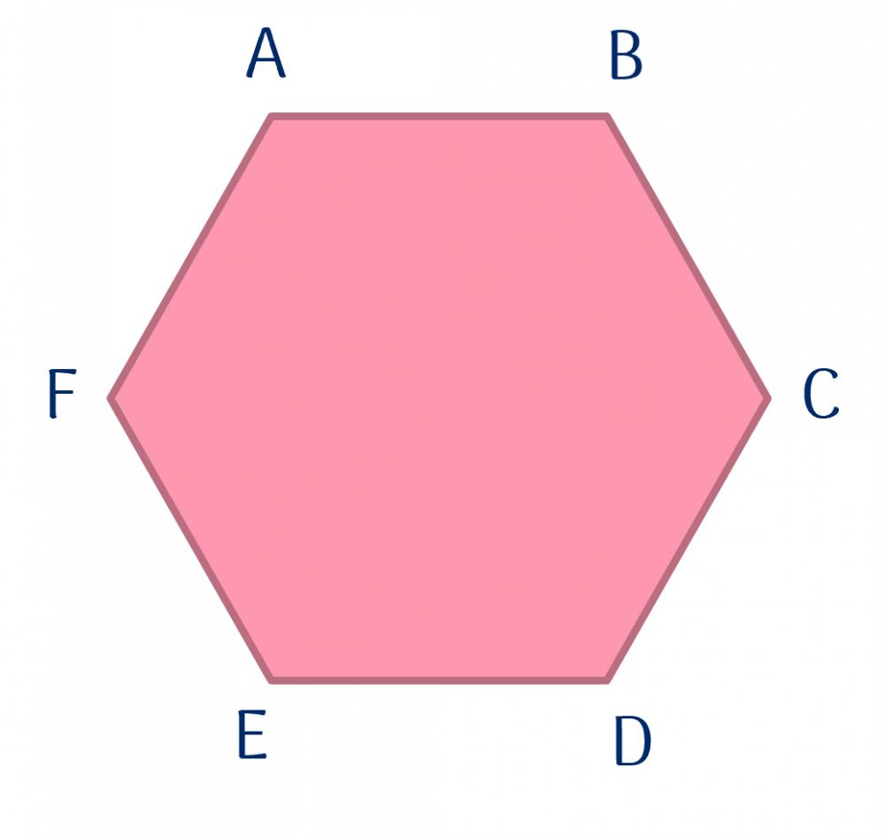
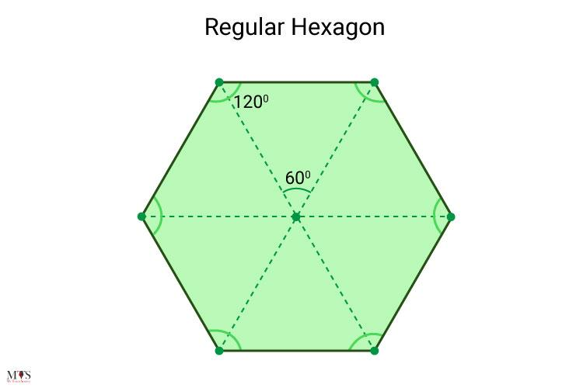
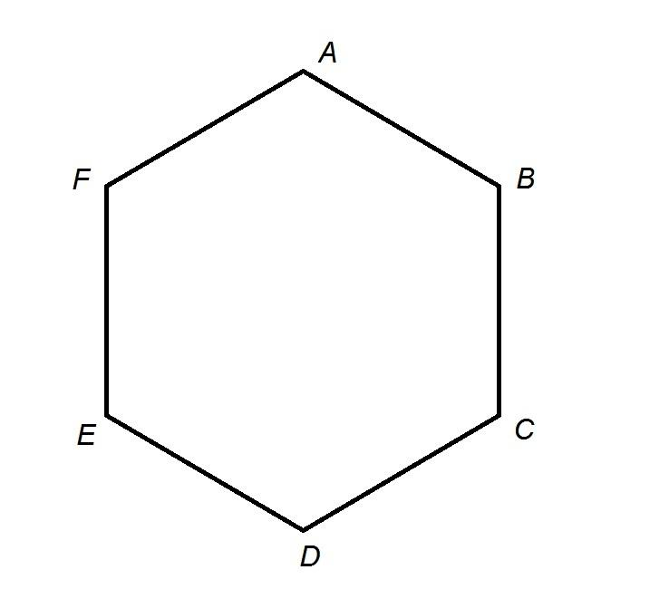
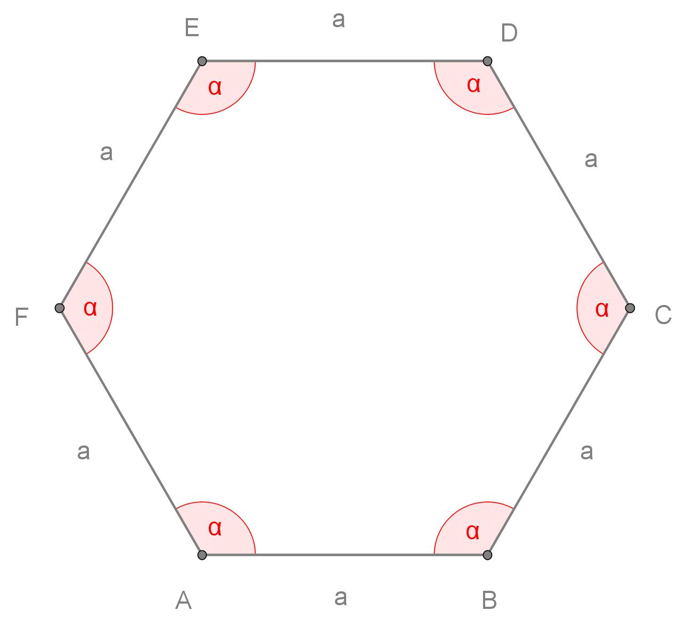
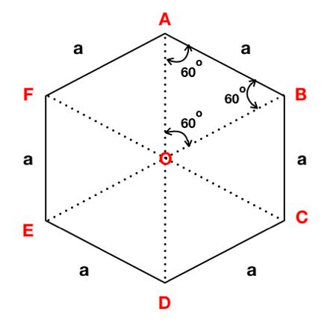

Fundamental Elements
# Source: AI Source: Provided by: [Data Path: Persons Table -> ID Column: 1, Name_En Column: Motasem Essam] -> From: [ChatGPT] on [7/25/2026]
A hexagon can be labeled:
$$\boxed{ABCDEF}$$
Its six sides are:
$$\overset{‾}{AB}, \overset{‾}{BC}, \overset{‾}{CD}, \overset{‾}{DE}, \overset{‾}{EF}, \overset{‾}{FA}$$
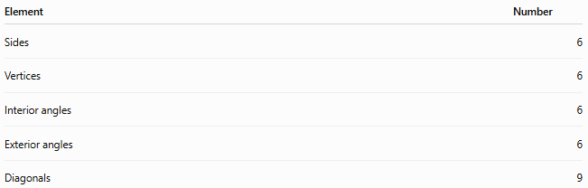
Element | Number
Sides | 6
Vertices | 6
Interior angles | 6
Exterior angles | 6
Diagonals | 9

Classification of Hexagons
# Source: AI Source: Provided by: [Data Path: Persons Table -> ID Column: 1, Name_En Column: Motasem Essam] -> From: [ChatGPT] on [7/25/2026]
Hexagons can be classified according to different geometric properties.
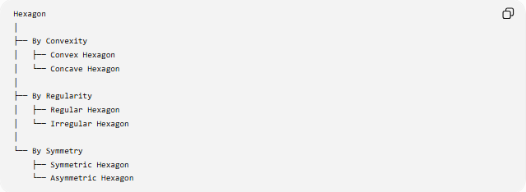
Hexagon
│
├── By Convexity
│ ├── Convex Hexagon
│ └── Concave Hexagon
│
├── By Regularity
│ ├── Regular Hexagon
│ └── Irregular Hexagon
│
└── By Symmetry
├── Symmetric Hexagon
└── Asymmetric Hexagon

1. Classification by Convexity

1.1 Convex Hexagon
# Source: AI Source: Provided by: [Data Path: Persons Table -> ID Column: 1, Name_En Column: Motasem Essam] -> From: [ChatGPT] on [7/25/2026]
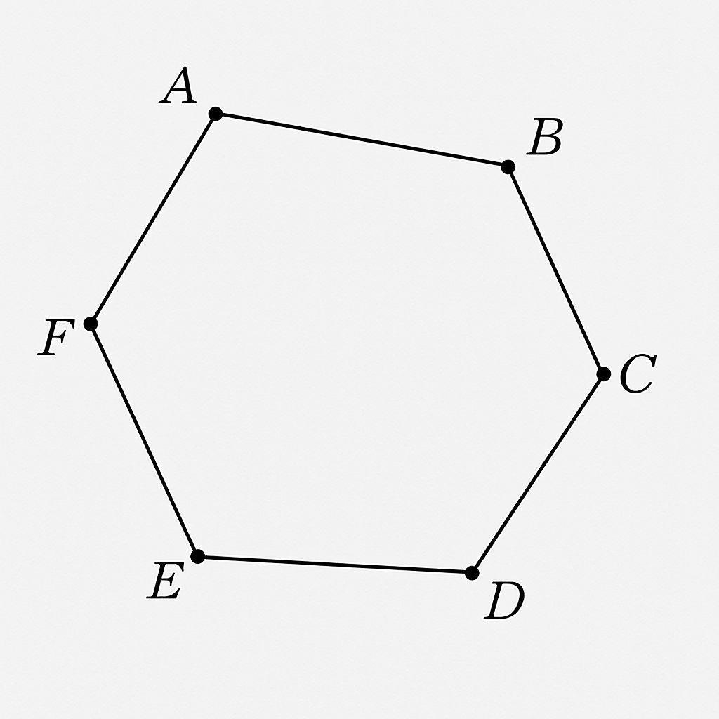
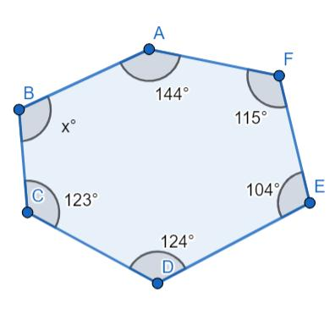
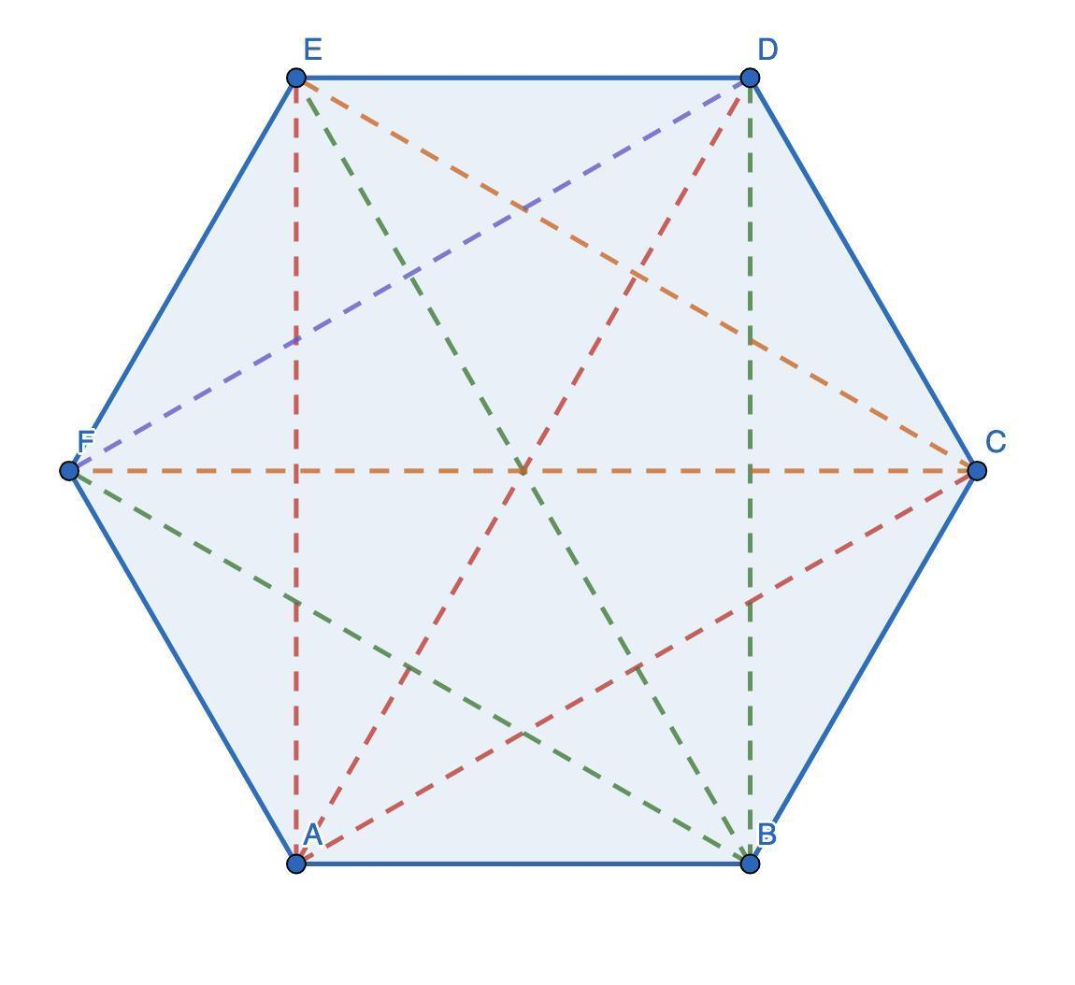
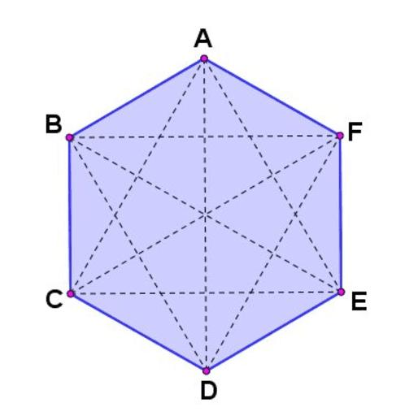
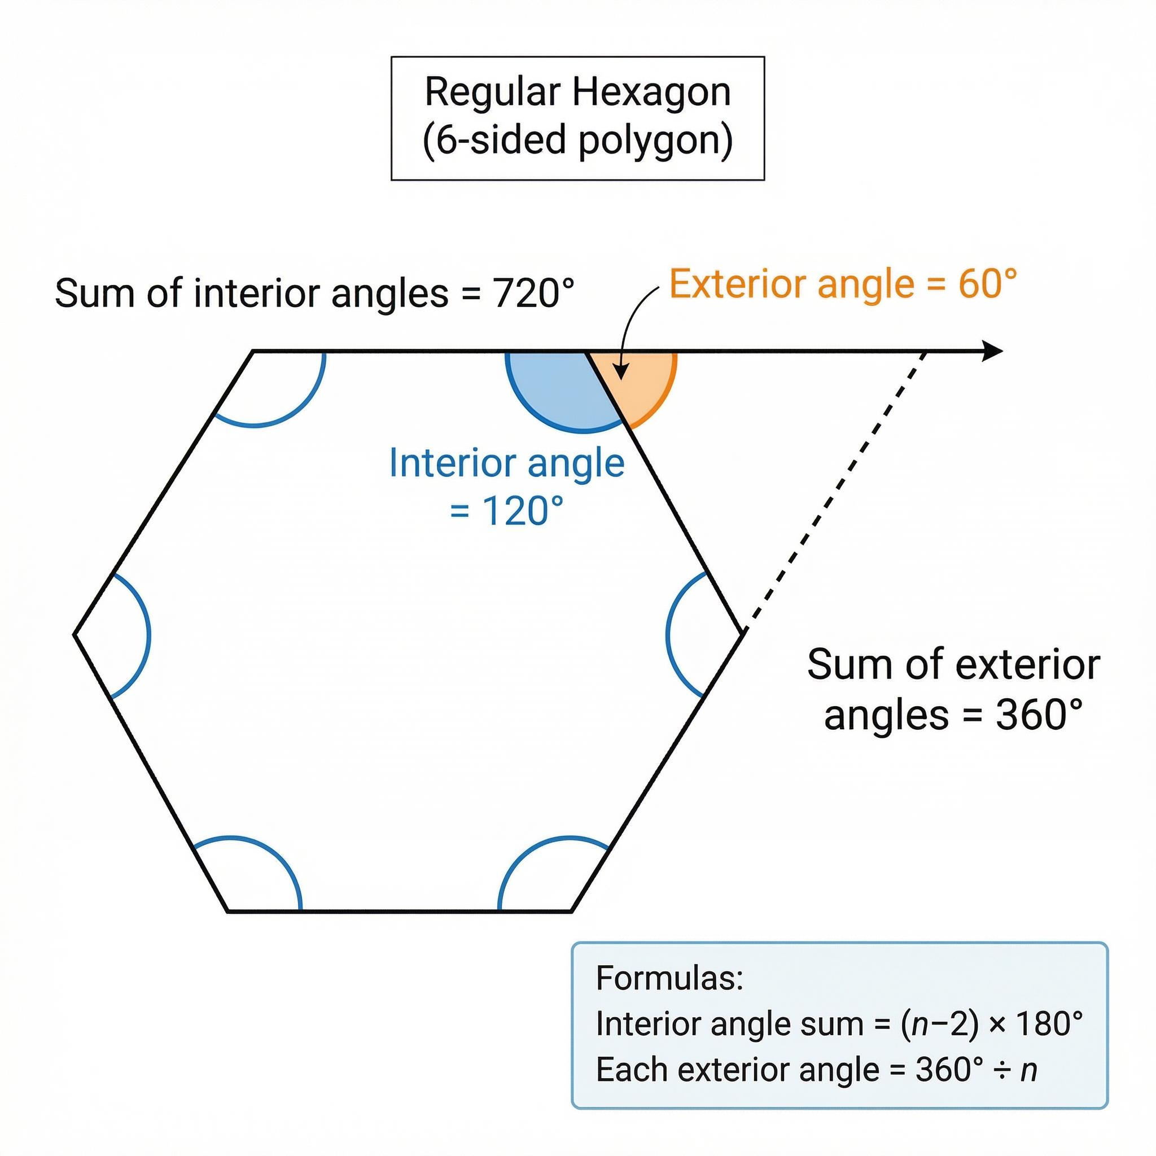
Definition
A convex hexagon is a hexagon in which every interior angle is less than ${180}^{∘}$.
$$\boxed{0^{∘}<∠A<{180}^{∘}}$$
for every interior angle.
Main Properties
- All six vertices point outward.
- No inward indentation exists.
- Every diagonal lies completely inside the hexagon.
- The interior-angle sum is ${720}^{∘}$.

1.2 Concave Hexagon
# Source: AI Source: Provided by: [Data Path: Persons Table -> ID Column: 1, Name_En Column: Motasem Essam] -> From: [ChatGPT] on [7/25/2026]
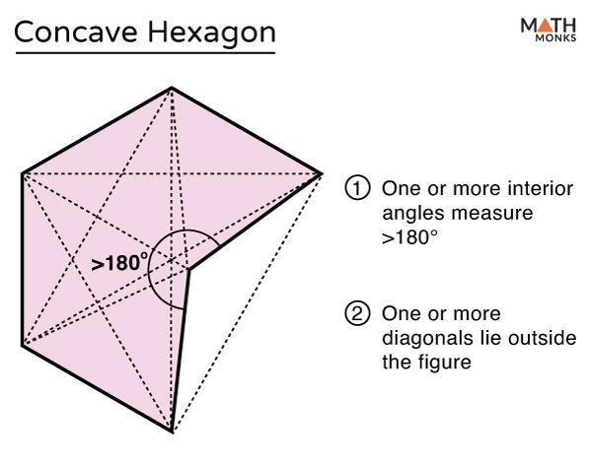
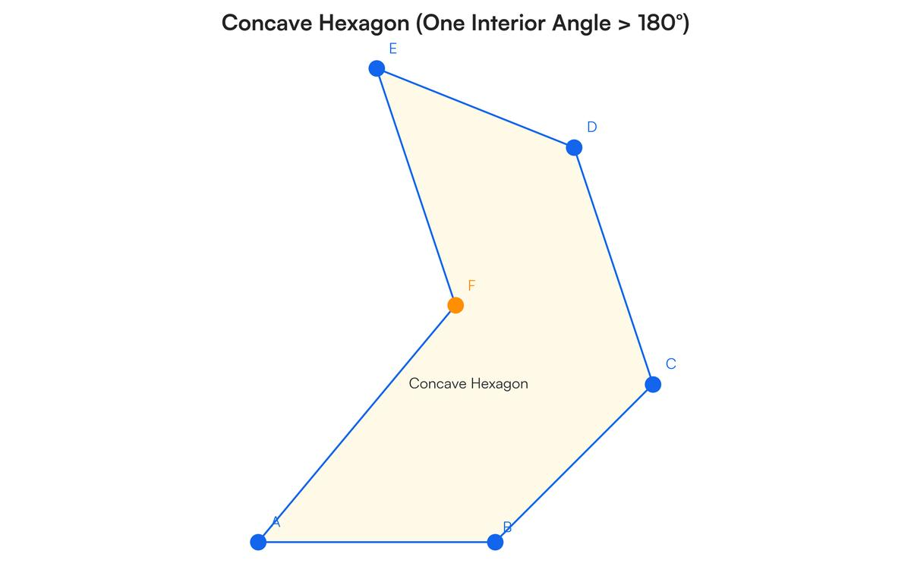
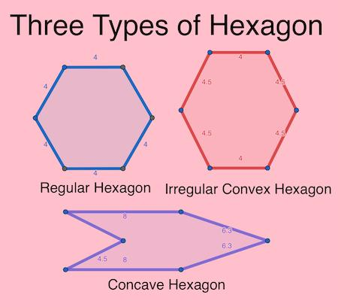
Definition
A concave hexagon is a hexagon with at least one interior angle greater than ${180}^{∘}$.
$$\boxed{{180}^{∘}<∠A<{360}^{∘}}$$
for at least one interior angle.
Main Properties
- It has at least one inward-pointing vertex.
- It contains an indentation.
- At least one diagonal lies partly outside the hexagon.
- It is not a convex polygon.

# Source: AI Source: Provided by: [Data Path: Persons Table -> ID Column: 1, Name_En Column: Motasem Essam] -> From: [ChatGPT] on [7/25/2026]

2. Classification by Regularity

2.1 Regular Hexagon
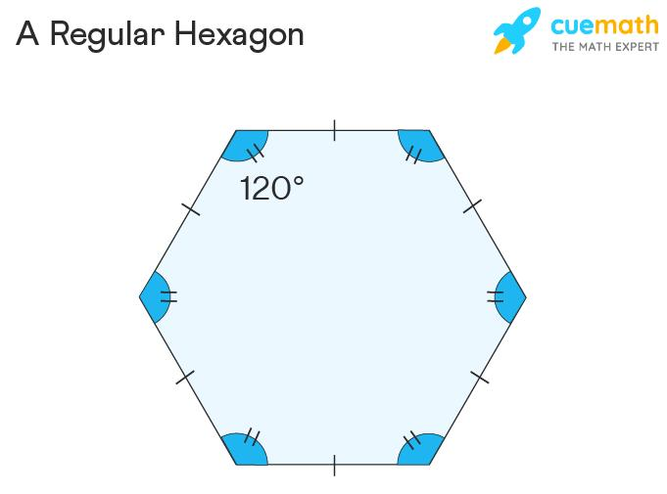
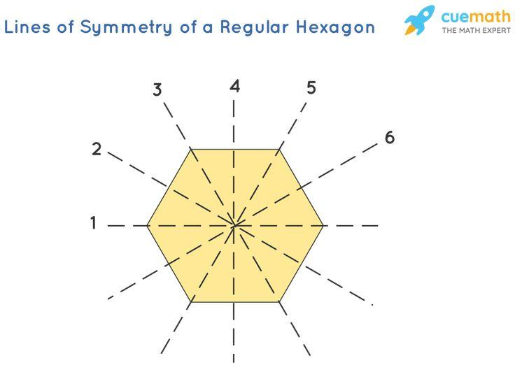
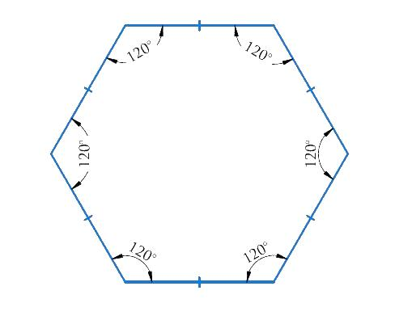
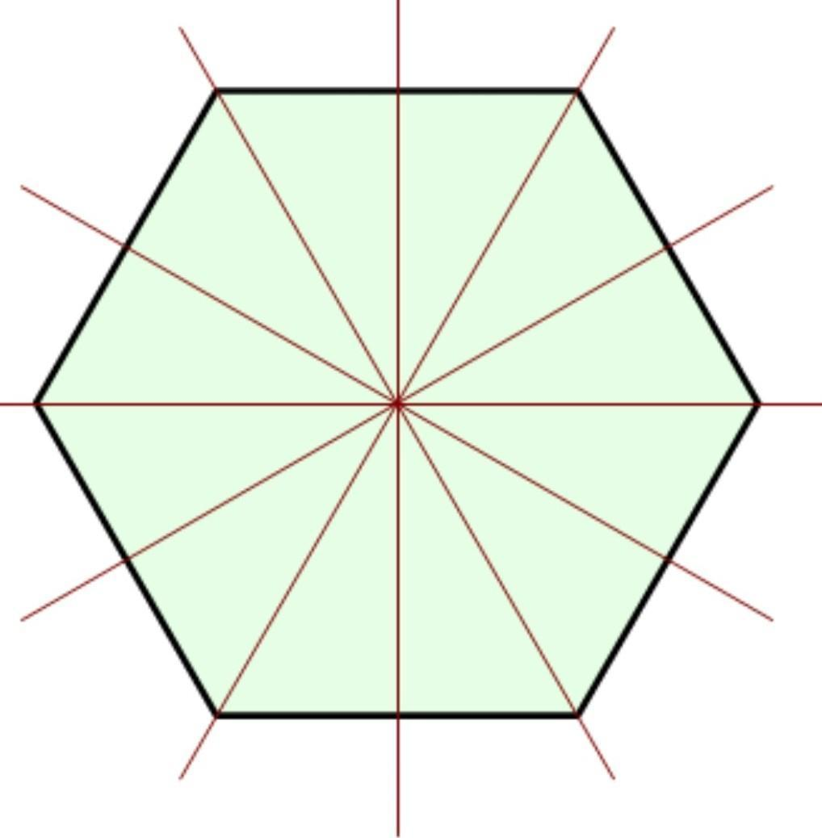
Definition
A regular hexagon is a hexagon with:
- six congruent sides;
- six congruent interior angles.
If the side length is $a$:
$$\boxed{AB=BC=CD=DE=EF=FA=a}$$
Each interior angle is:
$$\boxed{{120}^{∘}}$$
Each exterior angle is:
$$\boxed{{60}^{∘}}$$
Perimeter
$$\boxed{P=6a}$$
Central Angle
For a regular hexagon:
$$\frac{{360}^{∘}}{6}=\boxed{{60}^{∘}}$$
Symmetry
A regular hexagon has:
$$\boxed{6}$$
lines of symmetry and rotational symmetry of order:
$$\boxed{6}$$

2.2 Irregular Hexagon
# Source: AI Source: Provided by: [Data Path: Persons Table -> ID Column: 1, Name_En Column: Motasem Essam] -> From: [ChatGPT] on [7/25/2026]
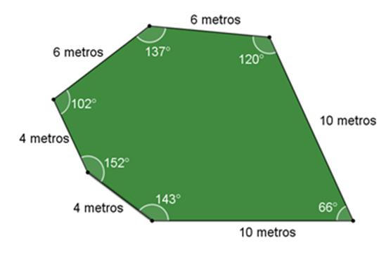
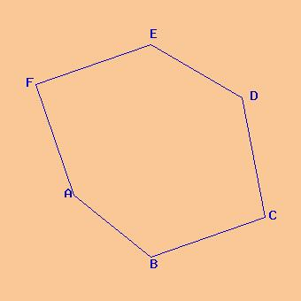
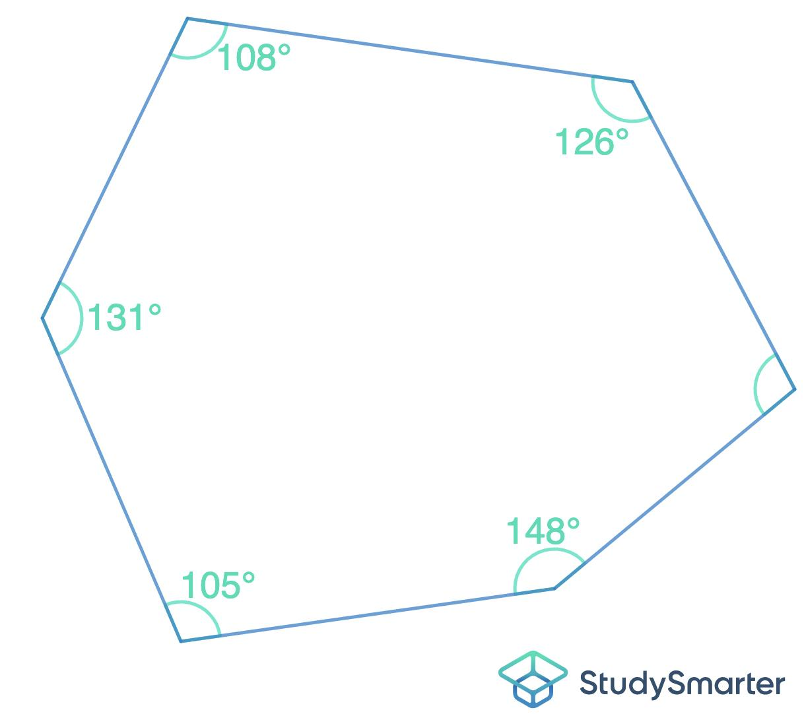
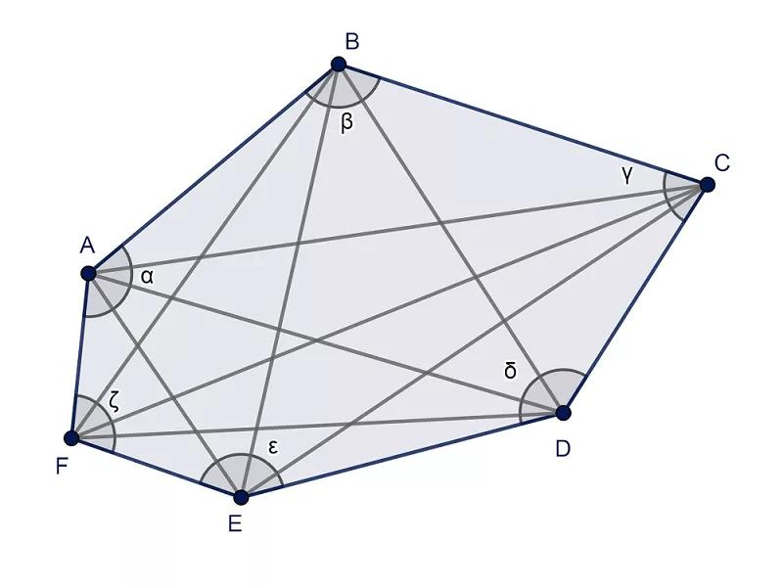
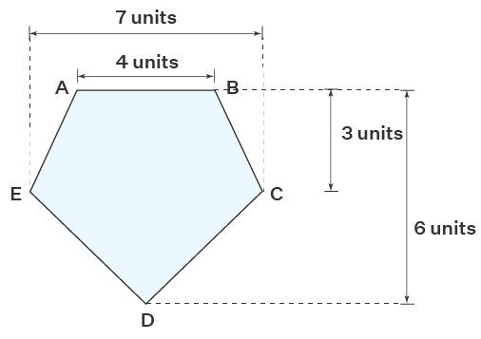
Definition
An irregular hexagon is a hexagon that does not have all six sides and all six interior angles equal.
It may have:
- unequal side lengths;
- unequal angles;
- some symmetry;
- no symmetry.
An irregular hexagon can be either convex or concave.
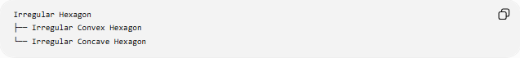
Irregular Hexagon
├── Irregular Convex Hexagon
└── Irregular Concave Hexagon

3. Classification by Symmetry

3.1 Symmetric Hexagon
# Source: AI Source: Provided by: [Data Path: Persons Table -> ID Column: 1, Name_En Column: Motasem Essam] -> From: [ChatGPT] on [7/25/2026]
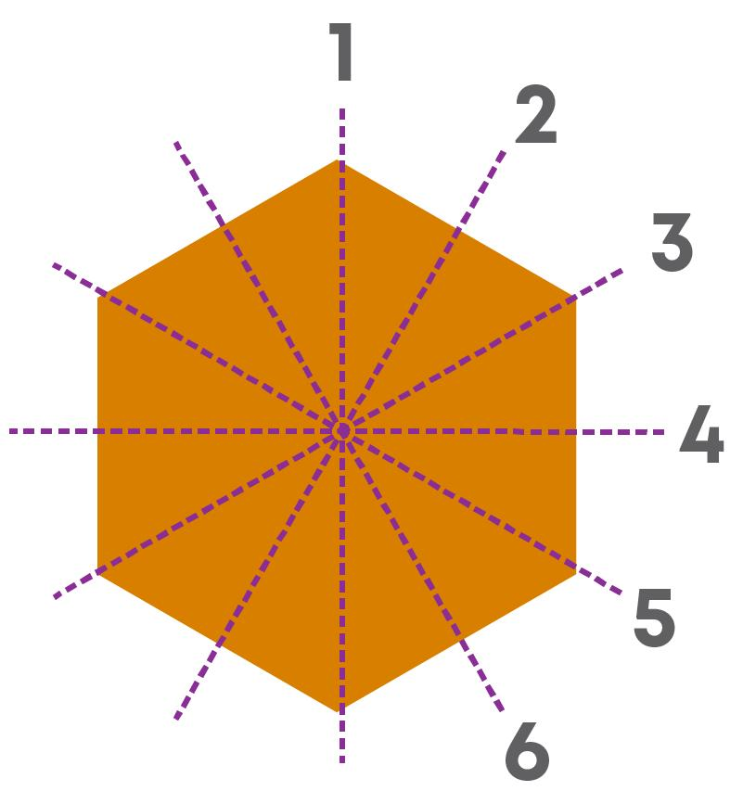
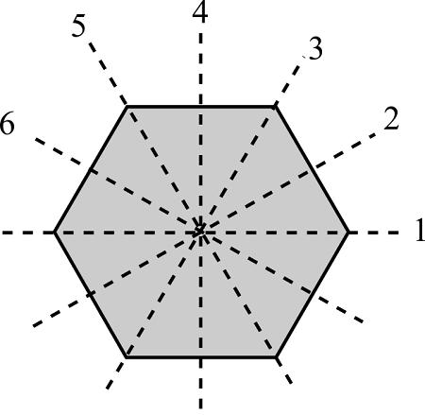
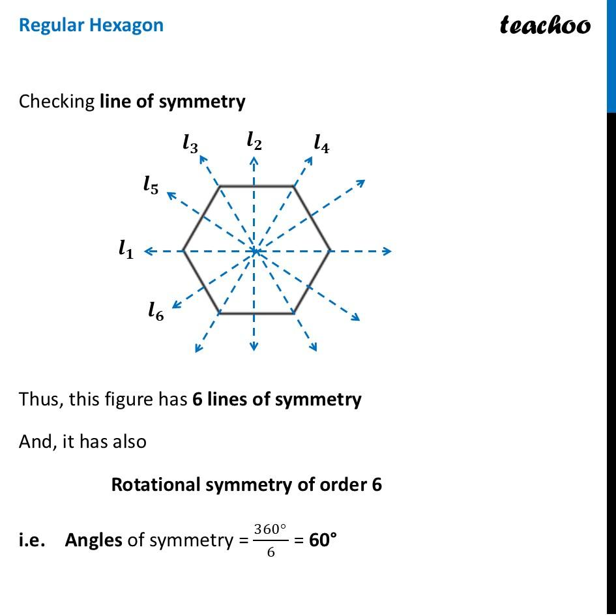
Definition
A symmetric hexagon has at least one form of geometric symmetry, such as:
- reflection symmetry;
- rotational symmetry.
A regular hexagon is highly symmetric.
It has:
$$\boxed{6\text{ lines of symmetry}}$$
and rotational symmetry of order:
$$\boxed{6}$$
Important Note
A symmetric hexagon does not necessarily have to be regular.
An irregular hexagon may have one or more lines of symmetry.

3.2 Asymmetric Hexagon
# Source: AI Source: Provided by: [Data Path: Persons Table -> ID Column: 1, Name_En Column: Motasem Essam] -> From: [ChatGPT] on [7/25/2026]
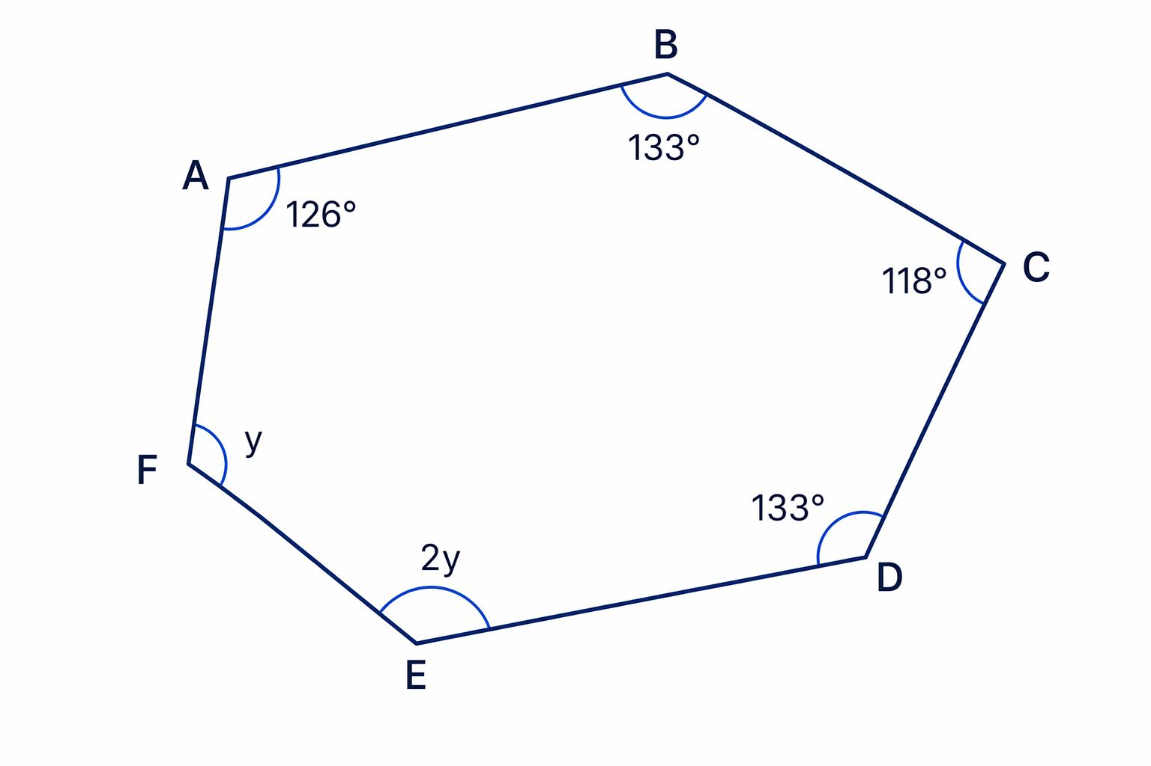
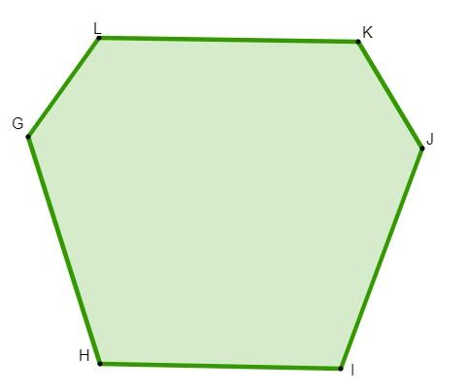
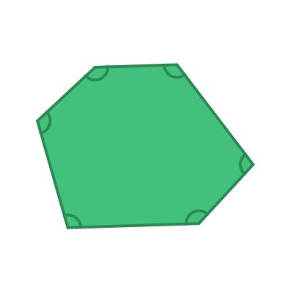
Definition
An asymmetric hexagon is a hexagon that has:
- no line of reflection symmetry;
- no non-trivial rotational symmetry.
Its shape has no symmetry that maps it onto itself.

Interior Angle Sum
# Source: AI Source: Provided by: [Data Path: Persons Table -> ID Column: 1, Name_En Column: Motasem Essam] -> From: [ChatGPT] on [7/25/2026]
The interior-angle sum of an $n$-sided polygon is:
$$\left(n-2\right)×{180}^{∘}$$
For a hexagon:
$$\left(6-2\right)×{180}^{∘} \\ 4×{180}^{∘} \\ \boxed{{720}^{∘}}$$
Therefore:
$$\boxed{∠A+∠B+∠C+∠D+∠E+∠F={720}^{∘}}$$
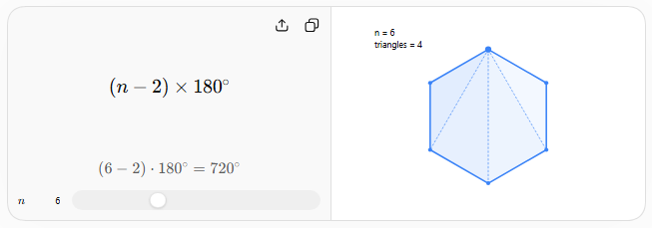

Regular Hexagon Angles
# Source: AI Source: Provided by: [Data Path: Persons Table -> ID Column: 1, Name_En Column: Motasem Essam] -> From: [ChatGPT] on [7/25/2026]
Since all six interior angles of a regular hexagon are equal:
$$\frac{{720}^{∘}}{6}=\boxed{{120}^{∘}}$$
Therefore:
$$\boxed{\text{Each interior angle}={120}^{∘}}$$
The exterior angle is:
$${180}^{∘}-{120}^{∘} \\ \boxed{{60}^{∘}}$$

Number of Diagonals
# Source: AI Source: Provided by: [Data Path: Persons Table -> ID Column: 1, Name_En Column: Motasem Essam] -> From: [ChatGPT] on [7/25/2026]
The number of diagonals of an $n$-sided polygon is:
$$\boxed{\frac{n\left(n-3\right)}{2}}$$
For a hexagon:
$$\frac{6\left(6-3\right)}{2}=\frac{6\left(3\right)}{2}=\boxed{9}$$
Therefore, a hexagon has:
$$\boxed{9\text{ diagonals}}$$
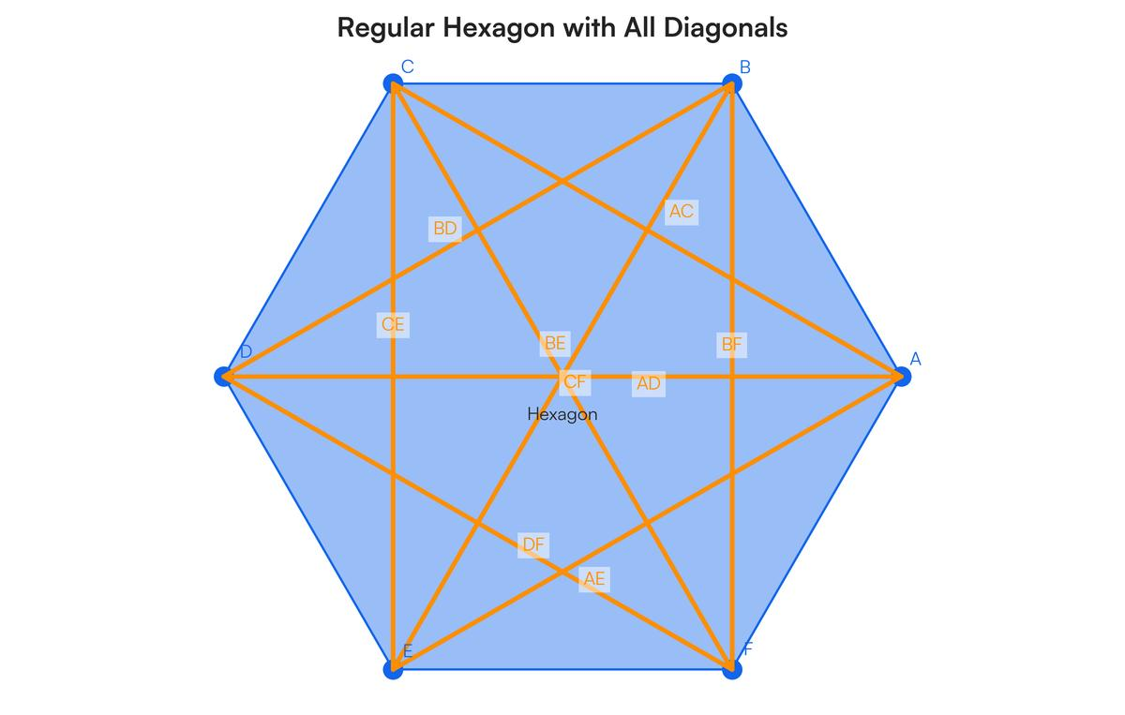
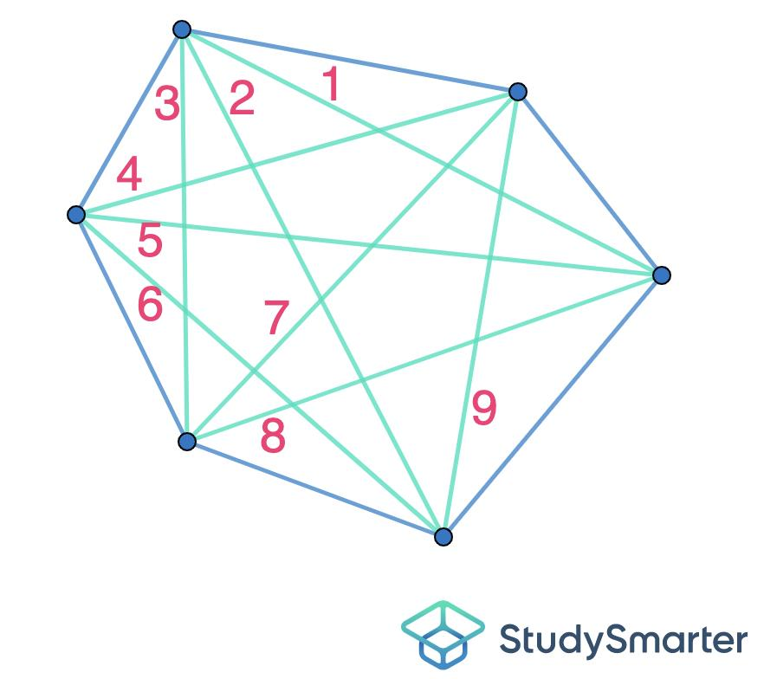
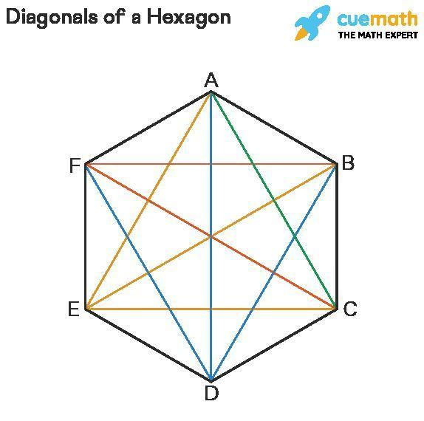
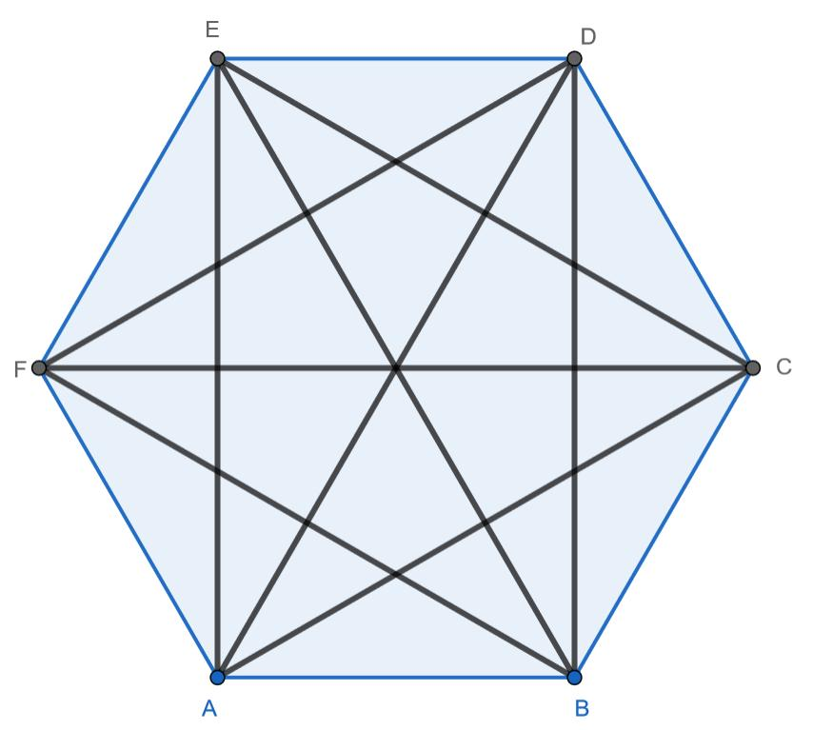

Regular Hexagon Measurements
# Source: AI Source: Provided by: [Data Path: Persons Table -> ID Column: 1, Name_En Column: Motasem Essam] -> From: [ChatGPT] on [7/25/2026]
Let the side length be $a$.
Perimeter
$$\boxed{P=6a}$$
Interior Angle
$$\boxed{{120}^{∘}}$$
Exterior Angle
$$\boxed{{60}^{∘}}$$
Central Angle
$$\boxed{{60}^{∘}}$$
Area
The area of a regular hexagon is:
$$\boxed{A=\frac{3\sqrt{3}}{2}a^{2}}$$
This comes from dividing the hexagon into six equilateral triangles.

Regular Hexagon and Equilateral Triangles
# Source: AI Source: Provided by: [Data Path: Persons Table -> ID Column: 1, Name_En Column: Motasem Essam] -> From: [ChatGPT] on [7/25/2026]
A regular hexagon can be divided from its center into six equilateral triangles.
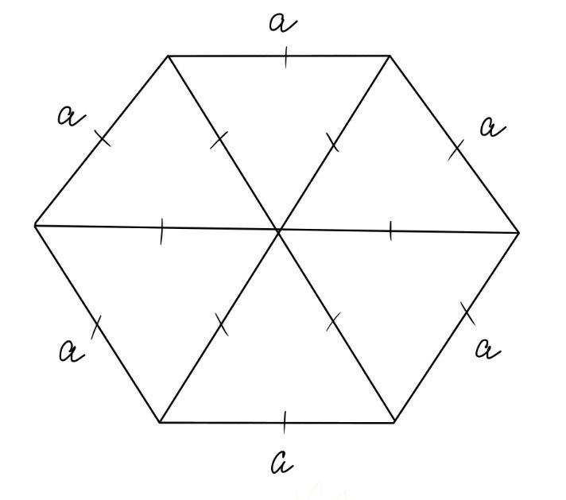
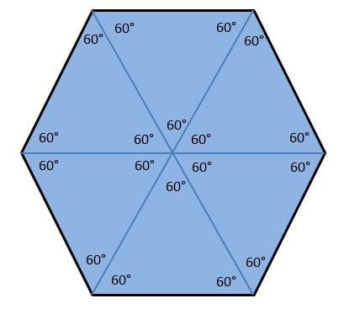
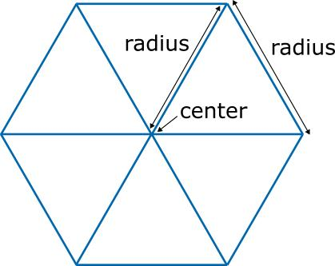
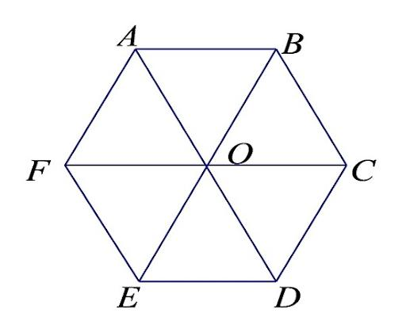
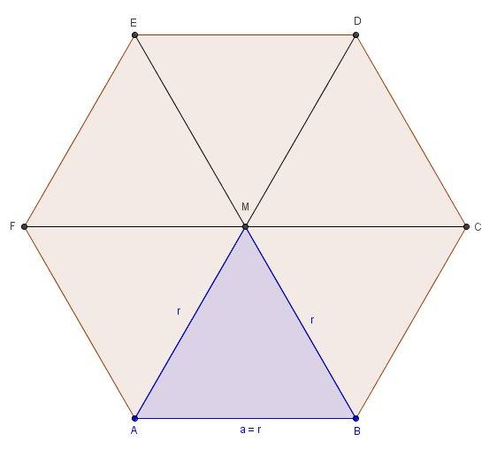
Each triangle has:
$${60}^{∘}+{60}^{∘}+{60}^{∘}={180}^{∘}$$
Therefore, the area is:
$$6\left(\frac{\sqrt{3}}{4}a^{2}\right)$$
which gives:
$$\boxed{A=\frac{3\sqrt{3}}{2}a^{2}}$$

Hexagon Diagonal Structure
# Source: AI Source: Provided by: [Data Path: Persons Table -> ID Column: 1, Name_En Column: Motasem Essam] -> From: [ChatGPT] on [7/25/2026]
From one vertex of a convex hexagon, diagonals can be drawn to:
$$6-3=3$$
other non-adjacent vertices.
Thus, each vertex has:
$$\boxed{3}$$
diagonals originating from it.
Counting all vertices gives:
$$6\left(3\right)=18$$
but every diagonal is counted twice, so:
$$\frac{18}{2}=\boxed{9}$$
diagonals.

Example 1 — Interior Angle Sum
# Source: AI Source: Provided by: [Data Path: Persons Table -> ID Column: 1, Name_En Column: Motasem Essam] -> From: [ChatGPT] on [7/25/2026]
Find the sum of the interior angles of a hexagon.
$$\left(6-2\right)×{180}^{∘} \\ \boxed{{720}^{∘}}$$

Example 2 — Regular Hexagon
# Source: AI Source: Provided by: [Data Path: Persons Table -> ID Column: 1, Name_En Column: Motasem Essam] -> From: [ChatGPT] on [7/25/2026]
A regular hexagon has side length:
$$a=8\text{ cm}$$
Its perimeter is:
$$P=6\left(8\right) \\ \boxed{P=48\text{ cm}}$$
Its area is:
$$A=\frac{3\sqrt{3}}{2}{\left(8\right)}^{2} \\ A=96\sqrt{3}$$
Therefore:
$$\boxed{A=96\sqrt{3}{\text{ cm}}^{2}}$$

Example 3 — Missing Angle
# Source: AI Source: Provided by: [Data Path: Persons Table -> ID Column: 1, Name_En Column: Motasem Essam] -> From: [ChatGPT] on [7/25/2026]
Suppose five interior angles of a hexagon are:
$${110}^{∘}, {120}^{∘}, {130}^{∘}, {100}^{∘}, {140}^{∘}$$
Their sum is:
$$110+120+130+100+140={600}^{∘}$$
The total is ${720}^{∘}$, so:
$$x={720}^{∘}-{600}^{∘} \\ \boxed{x={120}^{∘}}$$

Classification Summary
# Source: AI Source: Provided by: [Data Path: Persons Table -> ID Column: 1, Name_En Column: Motasem Essam] -> From: [ChatGPT] on [7/25/2026]
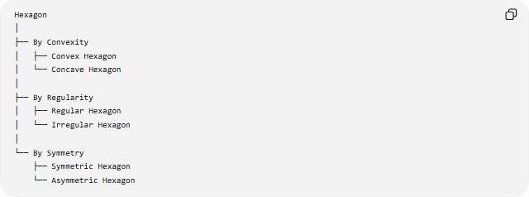
Hexagon
│
├── By Convexity
│ ├── Convex Hexagon
│ └── Concave Hexagon
│
├── By Regularity
│ ├── Regular Hexagon
│ └── Irregular Hexagon
│
└── By Symmetry
├── Symmetric Hexagon
└── Asymmetric Hexagon
These classifications can overlap.
For example:
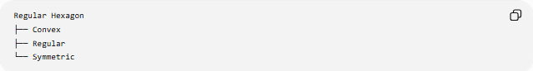
Regular Hexagon
├── Convex
├── Regular
└── Symmetric
while another hexagon could be:
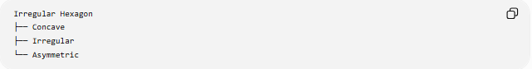
Irregular Hexagon
├── Concave
├── Irregular
└── Asymmetric

Relationship to Other Polygons
# Source: AI Source: Provided by: [Data Path: Persons Table -> ID Column: 1, Name_En Column: Motasem Essam] -> From: [ChatGPT] on [7/25/2026]
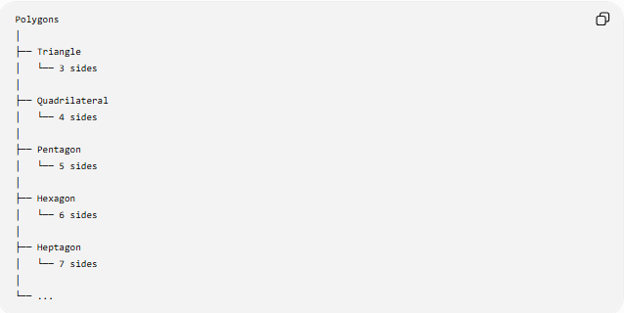
Polygons
│
├── Triangle
│ └── 3 sides
│
├── Quadrilateral
│ └── 4 sides
│
├── Pentagon
│ └── 5 sides
│
├── Hexagon
│ └── 6 sides
│
├── Heptagon
│ └── 7 sides
│
└── ...

Key Properties
# Source: AI Source: Provided by: [Data Path: Persons Table -> ID Column: 1, Name_En Column: Motasem Essam] -> From: [ChatGPT] on [7/25/2026]
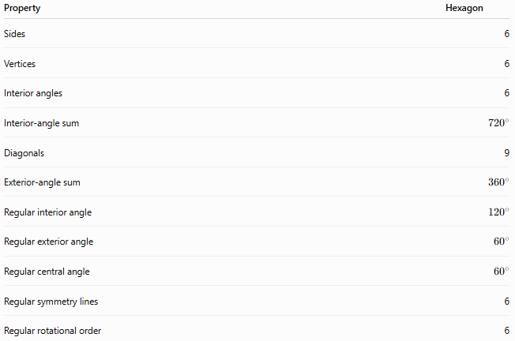
Property | Hexagon
Sides | 6
Vertices | 6
Interior angles | 6
Interior-angle sum | $${720}^{∘}$$
Diagonals | 9
Exterior-angle sum | $${360}^{∘}$$
Regular interior angle | $${120}^{∘}$$
Regular exterior angle | $${60}^{∘}$$
Regular central angle | $${60}^{∘}$$
Regular symmetry lines | 6
Regular rotational order | 6

Conclusion
# Source: AI Source: Provided by: [Data Path: Persons Table -> ID Column: 1, Name_En Column: Motasem Essam] -> From: [ChatGPT] on [7/25/2026]
A hexagon is a six-sided polygon. Its fundamental properties are:
$$\boxed{6\text{ sides}} \\ \boxed{6\text{ vertices}} \\ \boxed{{720}^{∘}\text{ interior-angle sum}} \\ \boxed{9\text{ diagonals}}$$
A regular hexagon has six equal sides, six equal ${120}^{∘}$interior angles, six lines of symmetry, and rotational symmetry of order $6$.

